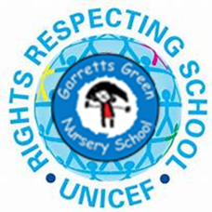 Thomas’ Diary 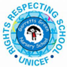

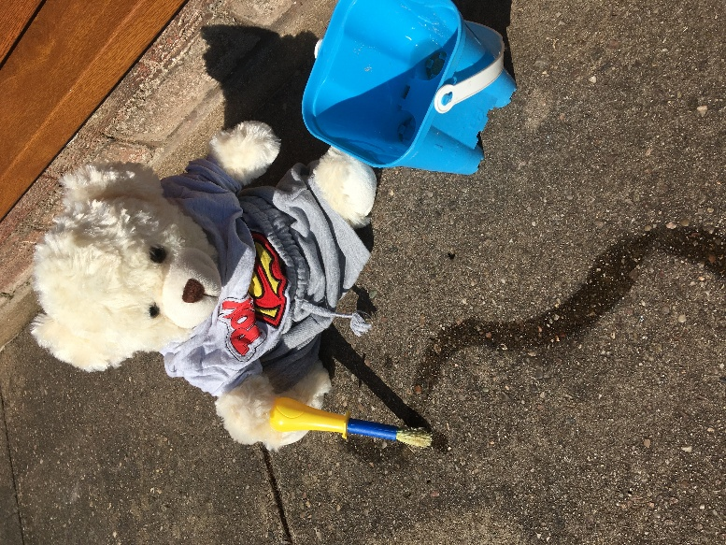

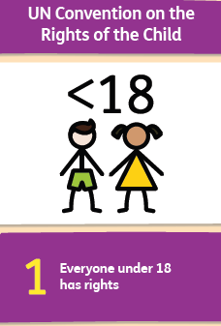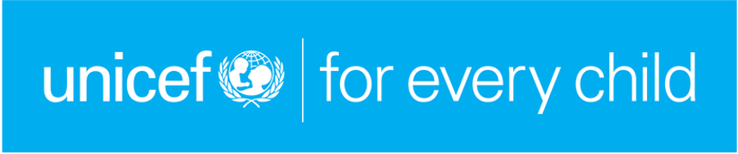
The United Nations Convention on the Rights of the Child
The United Nations Convention on the Rights of the Child has 54 articles that apply to all children around the world. As mentioned in a previous Memo we hope that our group bears will help the children to learn about their needs and rights and explore a select few by looking after their bears.
The ones that we will focus on are:

I have the right to a name (Article 7). 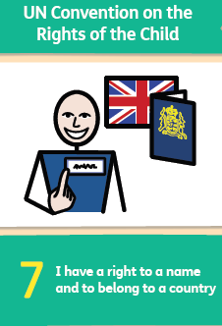

I have the right to be listened to and express myself, 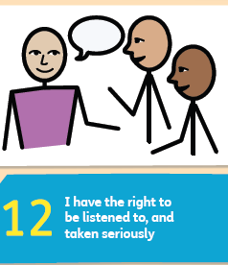
sharing my thoughts and feelings (Article 12 ) .

I have the right to live with a family who cares for me 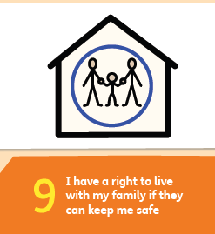
(Article 9).

I have the right to be safe (Article 19). 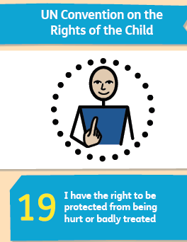

I have the right to healthy food, water and health care (Article 24) 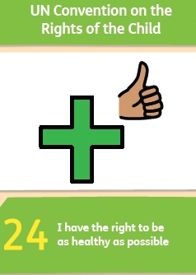

I have the right to have a proper home, 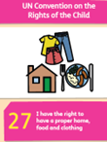
food and clothing (Article 27).

I have the right to an education (Article 27). 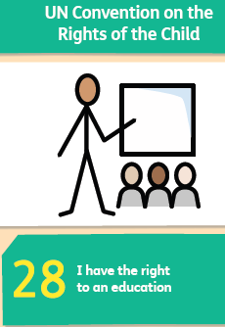

I have the right to play (Article 31) 